Ethan Allen Form Compressed Wooden Bed

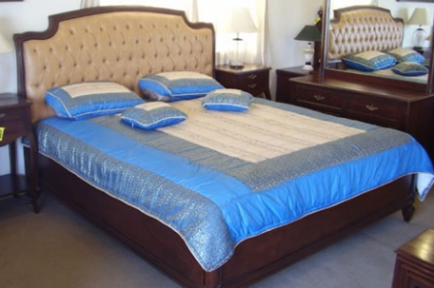

|  |
| --- |
| **DESCRIPTION** |
| Ethan Allen introduces a bed designed with hard form inserted in headed wood. This bed is guaranteed to create the perfect look in any house. The rich wood and form implanted in the wood gives the bed perfect look. The wood used in it is commonly known as planked wood which is used in a lot of furniture as it is resistance to wetness which protects the form. The comfortable level of this bed is very good. |

|  |  |  |
| --- | --- | --- |
| **Price** | **2100$** | |
| **Dimensions** | **H** x **W** x **L** | **34in x 50in x 73in** |
| **Features** | **Form absorbs heat to keep the bed constant in temperature and gives the bed perfect and durable look.** | |
| **Finished** | **Hard Polished Brown Wood** | |
| **Available in** | **Blue and Brown** | |